**Food in Space XML Config Manual**

**(Note: all of these instructions are for Window Operating System)**

**(For any further information and question, contact me: nhhai1605@gmail.com)**

1. For the first time running the simulation, please get into the scene first in order to let the program generate the default version for two XML files: SceneFoods.xml and SurveyQuestions.xml.
2. 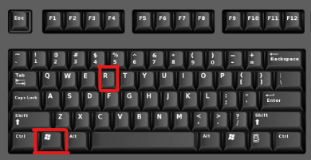Then, use command: ***“Window + R”***

Then type or copy and paste this path (without the quotes): **“%userprofile%\AppData\LocalLow\FoodInSpaceInc\ProgrammingProject”**

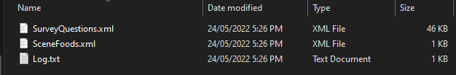Then, you should see 3 of these files (2 XML files and 1 txt file):

Note: The Survey Result csv/excel file also will appear here after you finished one survey.

1. In order to modify these XML files, you can use Notepad or XML Editor Online (<https://jsonformatter.org/xml-formatter/>) to edit the file. (The scale of the XML is not really big so I think use Notepad is easier and much simpler):

* 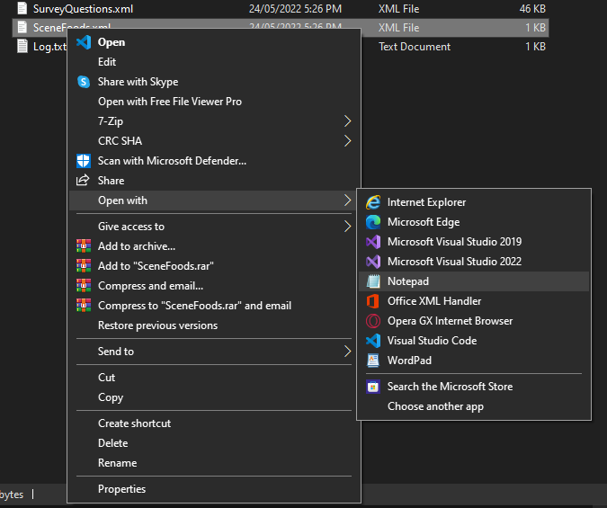Right click on the XML you want to edit, choose “Open With” and choose “Notepad”
* 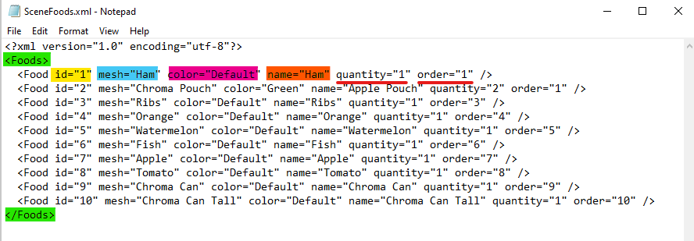And you will see this:
* For each Food in the Scene, there will be a food ID, a mesh / shape that that food will have, the colour, the name for the Survey, the quantity and the order to appear in the Scene. When you change any value for these parameters, remember the value has to be inside the quotes, likes **id = ”123”** or **name =  
  “Apple Pouch”.** Here is what each parameters mean:

1. **Food ID (highlighted in Yellow):** This is the ID will indicate which questions will appear for this Food (further information in the SurveyQuestions.xml). Spectators or Supervisors can see these Food IDs through a Food Tag with their spectator cameras but not the user who is experiencing the simulation. Multiple foods can have the same ID, then they will have the same question list. If you input 0 or negative or blank, the program will “comment out” the wrong line and announce you in the “Log.txt” file. (Note: “comment out” here is will make that line no longer work and affect the scene, then you can delete the line or “uncomment” it and fix the error based on the Log file)
2. **Mesh/Shape of the Food (highlighted in Light Blue):** This will be the shape or the mesh that Food ID will have. So, the Food with ID “1” now will have the Ham shape, the Food with ID “2” will have the Pouch shape. All of these meshes and shapes will be generated as a default version when you first run the program and it will let you know which shapes are available for you to use. If you input wrong or not existed meshes, the program will comment out that line)
3. **Colour of the Mesh for the Food (highlighted in Dark Pink):** This will be the colour of the mesh for the food. However, only some Foods that can customize the colour and you can know if the Food is colour customizable or not by the word “Chroma” in the name. For example, we are currently having 3 foods that can change its colours, which are the “Pouch”, the “Can” and the “Can Tall”. For these colour-customizable food, you can change the colour into these 9 colours: **White, Black, Blue, Green, Orange, Pink, Purple, Red, Yellow**. (**Note**: we might change to use Hex Colour like: **“#de5987”** for even more customization). If you input wrong, like “white” without capital “W” or “Whyte”, the program will comment the wrong line. The “Default” will indicate the default colour of the food and if you change the colour of the foods which are not colour customizable to “Red” or “Black”, the program will consider that line is wrong and comment out.
4. **Name of the Food (highlighted in Orange):** This will be the Name of Food that will appear in the Scene and in the Survey After the food get consumed. There are no restrictions for this one, you can have an empty name if you like but remember it still need a quote, like **name = “”** will indicate an empty name.
5. **Quantity and Order (underlined with Red):** These two values will be used for the number of that food will appear when it is its turn to appear. And the turn will be determined by the **order** value. The order will be from lowest to the highest, but the 0 and negative number will be considered wrong and will be commented out. For example, there are 3 foods with order 9, 29, and 4. The food with order 4 will appear first, then when you press the button in the scene, the food with order 9 will appear and next is 29. The **quantity** can also not be negative but it can be 0 if you don’t want it to appear in the scene.
6. **Add another Food:** If you want to add another Food, you can add a line following all the format and rule above and remember, it needs to be insides the <Foods> tag that I highlighted in Green.
7. Here is the parameter meaning in the SurveyQuestions.xml where you can customize the Survey question, the input and active and inactive. You can right click and choose “Open With” and choose “Notepad” the same way you edit the SceneFoods.xml.

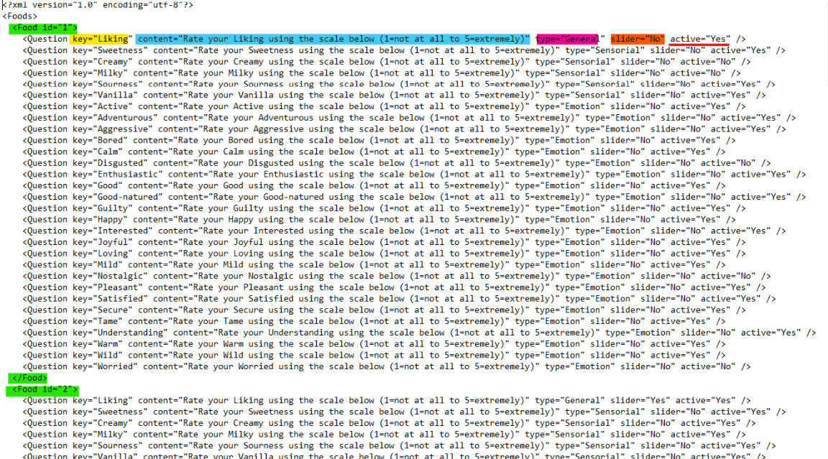

1. **The Key of the Question (highlighted in Yellow):** This will be the keyword for that question, **these keywords are fixed** and also be the keywords in the result csv file. You can change the order of them in the XML but in the survey, it will appear in a fixed order and it cannot be customized. If you input wrong or not existed Key, the line will be commented out. (Case sensitive)
2. **The content of the Question (will be highlighted in Light Blue):** This will be the wording of the question appear in the Survey and users will read this content for each question when doing the survey. It can be empty, but still need to be inside the quotes, like **content =””**.
3. **The type of the Question (will be highlighted in Dark Pink):** This will be the type of the question and they only used to letting you know what type of the Question is. Changing it will lead to an error and the program will comment it out. The order of question will appear in the Survey will be General -> Choose sensorial feels -> Chosen Sensorial -> Choose emotion feels -> Chosen Emotion and **this is fixed, not customizable.**
4. **The Input Type of the Question (will be highlighted in Orange):** This will determine how users will answer the Question. If it is a slider, then a score of a result will range from 1 to 9 when if it not a slider but check boxes, a score of a result will range from 1 to 5.
5. **The status of the Question (underlined with Red):** This will determine if the question is on or off for each Food ID. If the question is General and is inactive, the Survey will skip that question. If the question is Sensorial or Emotion and is inactive, the Survey will disable or black out the box when you choose which sensorial or emotions you experienced.
6. **Add another question:** Sorry but as I mentioned**, you cannot add a new question and the list of questions is fixed** because we will need to record the result in the csv. If a question has more than the total attributes than the other or have the different keyword, we cannot generate the csv file. Therefore, you should keep the same number of questions int the default version generated after you first run the simulation and **should only change the content, the input type and the status.**